Fulton-Hancock-McDonough-Schuyler Regional Board of School Trustees
Regional Office of Education #26 – Macomb, IL. Minutes – April 4, 2022
Zimmerman called to Order – 701p
Roll Call – Bair, McCain, Walker, Wilson, Zimmerman in attendance - Vancil absent
Visitors – Dave Demler
Consider Possible Additions/Deletions to the agenda
- None
Consider approval of minutes
- Motion by Wilson, Second by Walker – all in favor
Recognition of former president, Charles Fleming
- Presented and hung a plaque in memory of Mr. Fleming
Consider appointment to fill vacancy on the trustee board
- Motion to appoint John Marshall (Fulton Co.) to the open seat that expires in 2025.
  - Motion by McCain, Second by Walker – Roll Call (5 aye/0 no)
Statement of Economic Interest
- A new law was passed changing the form.
- Counties all approaching it a little different but take a look at the definitions provided.
- Due May 1, 2022
Update on ROE26 operations and/or regional schools
- A citizen has inquired about a potential detachment (LaHarpe to West Central)
- Have received several “no petition certificates” and have signed all. Regarding bonding by districts
- ROE26 received a community partnership grant from ISBE more than $600,000.
- ROE26 could see a significant increase in their ROE/ISC service line. The increase in in both the ISBE budget and Governor’s budget. Should be approved later this week.
- A lot of leadership turnover going on in ROE26 (Superintendents and Principals) because of retirements and better fits elsewhere.
- Major building projects in the region at Macomb, West Prairie, and Schuyler-Industry

Future Meeting Dates (all meetings will be in Macomb)
- July 11, 2022 - 700p – Macomb ROE26 Office
- October 3, 2022 - 700p – Macomb ROE26 Office
- January 9, 2022 - 700p – Macomb ROE26 Office
- April 3, 2023 - 700p – Macomb ROE26 Office
- May 22, 2023 - 700p – Macomb ROE26 Office (Reorganization Meeting)
  - Marshall, Walker, Wilson, Vancil up for re-election in 2023
Motion to Adjourn was made by McCain, seconded by Wilson. All in favor.
The meeting adjourned at 741p
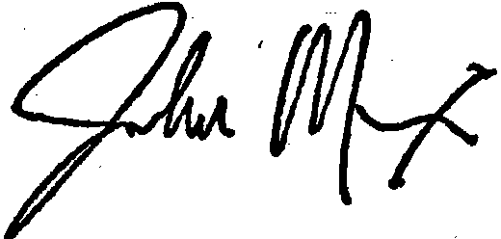
_________________________________________
John Meixner
Ex-officio Secretary

