Tips on Registering for the 2020 IAC Conference - Substance Abuse in Rural Communities." Register at: http://bit.ly/2020IAC

- Even though our registration site is set up for education, anyone can register for the Interagency Conference on April 22. Just put “other” and then type in none in any "required" areas that doesn’t apply to you. There’s also a pulldown menu that says "District" and you need to click on that and then click "Other" for your registration. Also, be sure that you’re clicking the box that says "I’m not a robot" prior to submit. The main things we need are your name, address, email and phone number. I usually put my work contact information for both work and home.

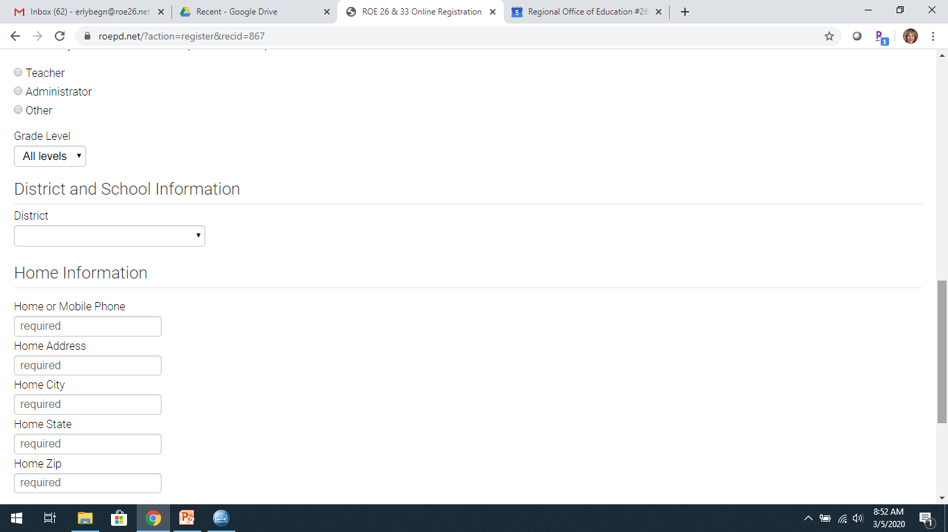

- We will be providing professional hours, CEU's and CPDU's for educators/teachers, LSW/LCSW, LCPC/LPC, QIDP.

- The conference is FREE and lunch will be provided from Jimmy John's for those who register.

- Parking is free and there is no need for a parking permit at the Spoon River Outreach Center in Macomb.

Looking forward to seeing everyone there!!!! :)

